When did Freemasonry start in Scotland?
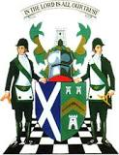

1736, they say but in truth freemasonry started in scotland many hundreds of years before that.

The 1736 date is when Scotland started its own Grand Lodge. Up until then they just never bothered.

The Grand Lodge of Antient, Free and Accepted Masons of Scotland is the governing body of Freemasonry in Scotland. It was founded in 1736.

About one third of Scotland's lodges were represented at the foundation meeting of the Grand Lodge.

There are records in existence today that prove that Freemasonry existed in Scotland in the early 1500s.

Let there be no doubt, the Scots were first in the UK.

